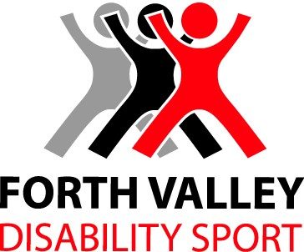

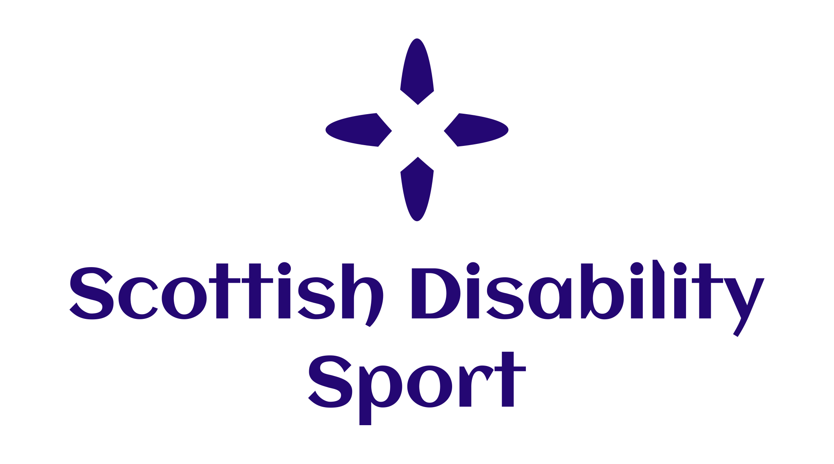
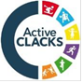


Central Disability Sport Coach Education Calendar

Academic Year 2019- 2020

Note: All courses and workshops can be accessed by coaches, volunteers, teachers/ support staff, local authority representatives and NHS partners from the Forth Valley area

Sports Makaton Sign Sharing Workshop
The course is aimed at anyone who is working in sport and can assist those with communication difficulties. Makaton signs will aid to support their understanding whilst participating in sports activities. The course will teach some core vocabulary signs, and a small selection of topic signs.

Venue: Grangemouth Sports Complex
Date: Monday 16th September 2019
Time: 4.00pm – 6.00pm
Cost: No cost to Forth Valley individuals/ representatives
To book: For more information on this course please contact lisa.male@falkirkcommunitytrust.org

UK Disability Inclusion Training: Autism Workshop

This is an excellent introductory workshop into disability sport in Scotland. This course provides delegates with the following opportunities
• To recognise and influence how perceptions and experience have on interactions and our expectations of others
• Identify appropriate disability‐specific terminology, etiquette and communication
• Articulate the principles of current legislation and know who to contact for further information
• Outline the barriers which may need to be challenged in order to create opportunity
• Identify the participation opportunities within disability sport
• Recognise how to influence (even change) practices and facilitate inclusion

Course: Disability Inclusion Autism Training
Venue: Alloa Academy
Date: Thursday 26th September 2019
Time: 5.30pm – 8.30pm
Cost: No cost to Forth Valley individuals/ representatives
To book: Contact Jackelyn Perez at JPerez@clacks.gov.uk or on 01259 452340

Boccia UKCC Level 1

The course will cover:
- Planning and preparation
- Effective communication and demonstration skills
- How to give appropriate and constructive feedback
- Evaluating activities
- Understanding of boccia and coaching principles

Venue: Annan Academy
Date: Saturday 28th and Sunday 29th September 2019
Time: 9.00am – 5.00pm
Cost: £250.00 with £75.00 subsidy from sportscotland
To book: Contact Caroline Lyon at admin@scottishdisabilitysport.com or on 0131 317 1130 to book and for subsidy information

Soft Archery Training
This workshop designed for coaches/teachers and volunteers interested in working with athletes in Archery. This workshop will cover practical and workshop teaching methods to offer coaches an insight into archery and how to best athletes with differing abilities. Archery is a very inclusive sport and has been used in other areas to assist with those who have not previously engaged in sport.

Venue: Grangemouth High School
Date: Wednesday 2nd October 2019
Time: 5.30pm – 8.30pm
Cost: No cost to Forth Valley individuals/ representatives
To book: contact Lisa Male at Falkirk Community Trust Lisa.Male@falkirkcommunitytrust.org
to book your place on this workshop

Disability Inclusion Training - Athletics

This workshop has been designed for coaches interested or already working with athletes with a disability. They will be led by experienced Scottish Disability Sport/UKA coaches. Workshop will cover aspects of disability awareness, classification, competition structures and opportunities for practical ‘hands on’ coaching.

Venue: Grangemouth Sports Stadium
Date: Monday 7th October 2019
Time: 5.30-8.30pm
Cost : No cost to Forth Valley individuals/ representatives
To book: contact Shona Malcolm on 0131 539 7348 or shonamalcolm@scottishathletics.org.uk

Inclusive Tennis Workshop
This workshop designed for coaches interested in working with athletes within tennis. This workshop will cover practical and workshop teaching methods to offer coaches an insight into how to best deliver tennis to players with different and differing abilities.
Tennis is a fully inclusive sport. It can be adapted into different formats to enable young people with a range of disabilities to play and enjoy the game.

Venue: Grangemouth High School
Date: Monday 28th October 2019
Time: 5.30om – 8.30pm
Cost: No cost to Forth Valley individuals/ representatives
To book: contact Lisa Male at Falkirk Community Trust Lisa.Male@falkirkcommunitytrust.org
to book your place on this workshop

Sports Makaton Sign Sharing Workshop
The course is aimed at anyone who is working in sport and can assist those with communication difficulties. Makaton signs will aid to support their understanding whilst participating in sports activities. The course will teach some core vocabulary signs, and a small selection of topic signs.

Venue: Grangemouth Sports Complex
Date: Monday 25th November 2019
Time: 4.00pm – 6.00pm
Cost: No cost to Forth Valley individuals/ representatives
To book: For more information on this course please contact lisa.male@falkirkcommunitytrust.org

Inclusive Cricket Workshop
This workshop designed for coaches/teachers and volunteers interested in working with athletes in Cricket. This workshop will cover practical and workshop teaching methods to offer coaches an insight table and soft cricket.

Venue: Falkirk Venue, TBC
Date: Wednesday 27th November 2019
Time: 5.00pm – 7.00pm
Cost: No cost to Forth Valley individuals/ representatives
To book: For more information on this course please contact lisa.male@falkirkcommunitytrust.org

Scottish Swimming -Inclusive Coaching Workshop

Venue: Stirling University Swimming Pool
Date: Sunday 2nd February 2020
Time: 12:30 – 5:30pm
Cost : No cost to Forth Valley representatives via GOGA
To book: contact Paul Wilson p.wilson@scottishswimming.com
to book your place on this workshop

Central Disability Sport Contact Details

Organisation | Lead officer  Disability Sport | Telephone Number | Email address
Scottish Disability Sport | Cheryl Lappin (Willet) | 07577 830360 | cheryl.lappin@scottishdisabilitysport.com
Forth Valley Disability Sport | Graham Harvey | 01786 466485  07527 147685 | graham.harvey@fvds.org.uk
Active Stirling | Colin Naismith | 0300 028 0101 | naismithc@activestirling.org.uk
Clackmannanshire Council | Jackie Perez | 01259 452340 | jperez@clacks.gov.uk
Falkirk Community Trust | Lisa Male | 01324 590931 | lisa.male@falkirkcommunitytrust.org

